Mobile Application Environments

To ease the process of testing and development, I have created three environments.

# **Mock**

The application is in mock mode, meaning you do not have to input all the fields to advance to next screen. You can press buttons to navigate through the app.

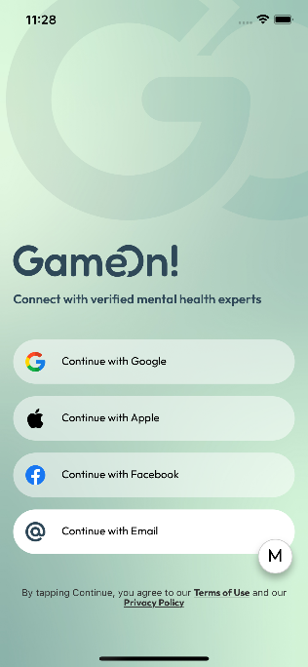

When app is MOCK mode, this badge will show, you can click to hide this badge.

# **Development - DEV**

The application is purely functional, but it is connected to development database, so that malfunctions do not corrupt the production data.

# **Production - PROD**

The application is connected to production server and real data. Only stable code should be in PROD mode.